**Tableau dataviz challenge Project Report**

ON

**“Employment** **”**

Submitted for the Tableau dataviz challenge of

BY

**NAME: RAHUL P.BHERE**

**A project report submitted to:**

Smart Bridge



**ACKNOWLEDGMENT:**

The success and outcome of this project required guidance and assistance from **Smart Bridge**. I am extremely privileged to have got this all along with the completion of my project. All that I have done is only due to such supervision and assistance and I would not forget to thank them. I thank **Smart Bridge**, for providing me an opportunity to do the project work in the Tableau dataviz challenge **Employment** and giving me all support and guidance which made me complete the project duly. I am extremely thankful to smart bridge for providing such a nice support and guidance.

**EMPLOYMENT DATA VISUALIZATION** **USING TABLEAU**

The story telling dashboard that i have created from the dataset is about EMPLOYMENT and its variation in every sector.I have selected some of the best sectors from which a clear visualization can be done easily.

People like new entrepreneurs ,the government people and common people will have a brief idea about the employment percentages, where there is less employment and area where the entrepreneurs should target to build a strong start up.

With the help of this visualization one can easily understand the areas where employment is in hike and as well as not preffered.

# PROBLEM

NOWADAYS PEOPLE BELIEVE THAT ONLY EXPERIENCE IN ANY FIELD CAN HELP THEIR ORGANIZATIONS STAND.

BUT THE POINT TO BE NOTED IS EVEN EXPERIENCE COMES FROM PRACTICE DETERMINATION AND HARD WORK.

MANY ORGANIZATIONS MAY IT BE FROM SMALL SCALE TO LARGE SCALE OF VARIOUS SECTORS CAN BE DEVELOPED PART BY PART BY FOLLOWING THIS SOLUTION (IN MY PRACTICAL WAY OF THINKING).

**SOLUTION**

* I came up with the following data analysis that every sector growth is not only determined by education but its skills.
* With the help of dataset available at data.gov.in website i have fetched up the employment data details from early 2000's to 2010.
* From the data one can analyse the exact situation of various sectors employments that were taking place in the years 1999's to 2010.
* At that time india was not very much into the field of entrepreneurship s.
* But this analysis can help every entrepreneur around india to exactly find the people and sector they want to target and provide them employments in such a way that even they get benefitted by improving their skills and bring good momentum to their primary start

ups.

* For example: the given down picture represents the data of various sectors employments

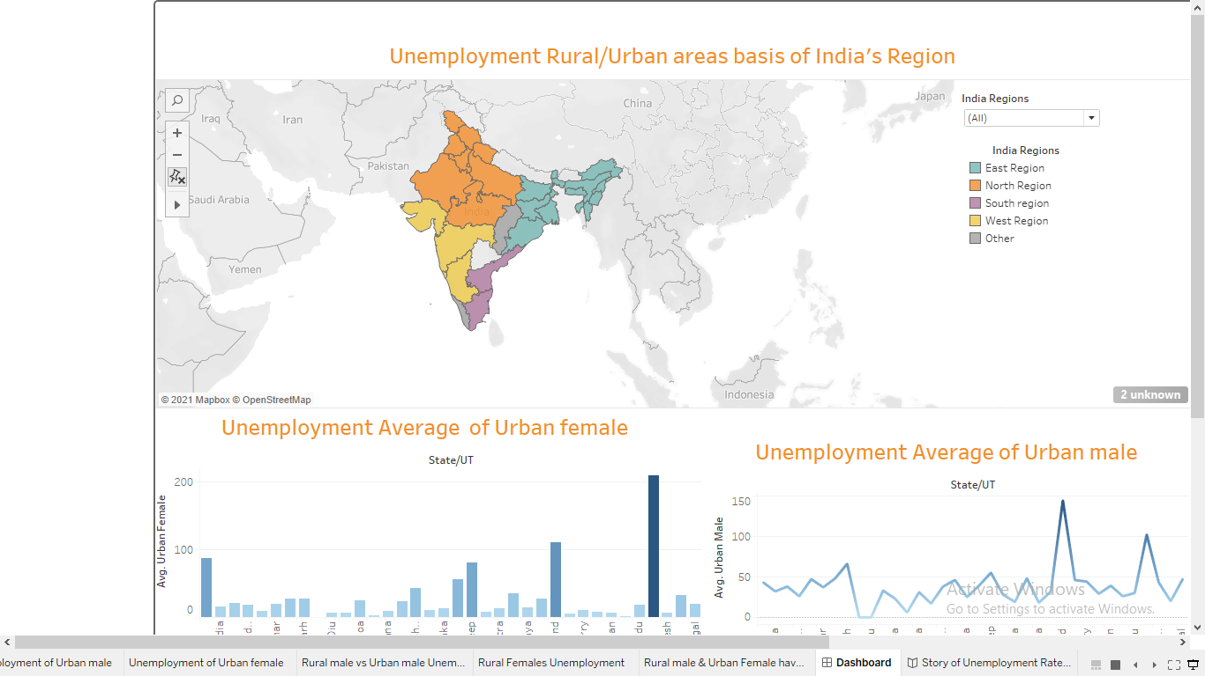

* AGRICULTURE SECTOR have seen several ups and downs from the data and is neglected nowadays an active organization can target this sector by employing this particular field people by paying monthly wages and having a direct communication with them for a deal. Even any new entrepreneur can directly approach agriculture sector and start a good startup in which farmers and other agricultural are benefited.
* People can also have this data and its changes in mind before going to any sector where they want to make their future.
* now the above picture just shows the status, where as how could be the fluctuations be for this the data can be visually analyzed like this which shows the changes that ● happened in the above mentioned years.
* the above data viz helps an individual to understand the fluctuations that takes place in a particular sector.
* Now with these data viz again with various datasets i have gathered the information on no of workers from various areas of india and again we can further make a data viz on

which can be seperately calculated on basis of male and female category/power.

* This helps any person to understand the changing scenarios from past years to current days.

Now another thing people consider is education as primary thing i.e not knowledge but marks but this clearly has shown wrong and only those organizations have been in the path of success who employee their people who have skills.. This can be practically shown with a data viz of unemployment of people on basis of education .

2. MICROSOFT EXCEL



1. One can get clarity on employment sectors whenever he refers this data viz in the future.
2. People will start developing themselves better in their sectors or try to go for a better sector.
3. It motivates one that skills are greater extent than the eeducation.
4. Skills will be given most importance in any employment.
5. The number of rural and urban workers will show how well there is an establishment of workers all over the places and how entusiastic people are for working .
6. Entrepreneurs can easily work with those sectors and work in an creative ways to solve problems as well as to make profits .

## RESULT

The final dashboards obtained when using all these individual worksheets as follows: